Pan-European University Apeiron
Report on the dissemination of the experience of participating in the Erasmus+ program
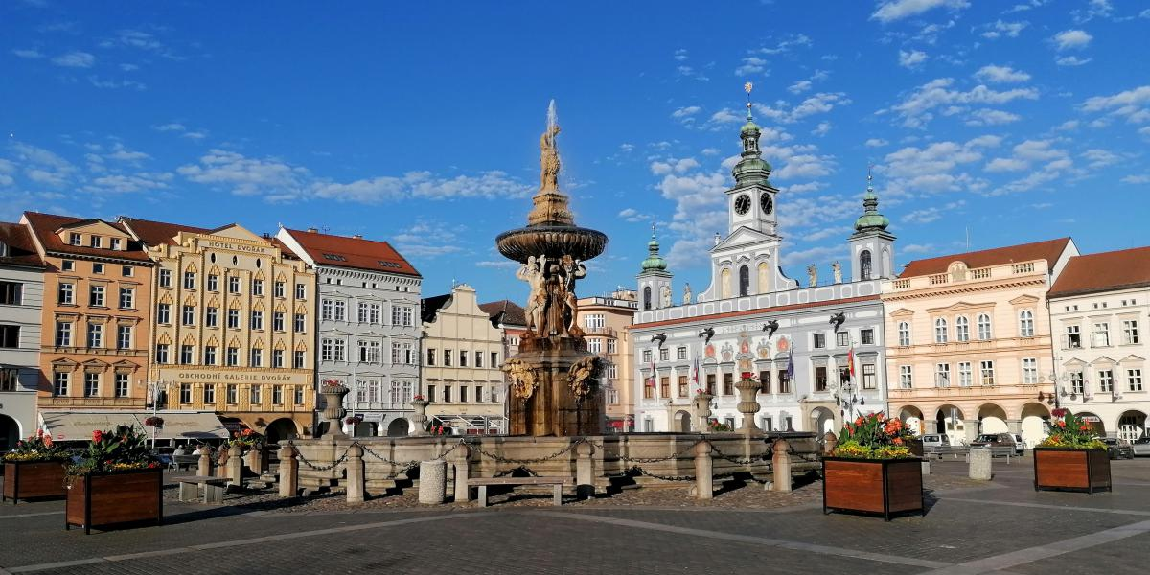

As part of the Erasmus+ program, the Pan-European University Apeiron is cooperating with the Faculty of Health Sciences at the University of South Bohemia. The European Union funds this project and financial resources have been allocated for the exchange of academic and non-academic staff as well as students.
The Office for International Cooperation received 1 application for the published competition for a two-month exchange of students at the mentioned university. Student Marko Babić did his professional practice in the period 17.07.-16.09.2022, where he visited spas and rehabilitation centers in and around České Budejovice and got acquainted with new methods and work techniques.
The goal of this exchange was to gain new experiences during his stay in another country, to make contacts and connect with students from all parts of the world, as well as to acquire new knowledge and skills with work methods used in other rehabilitation centers.
After returning to the Pan-European University Apeiron, Marko Babić on 30.09.2023. held the dissemination of the experience of participating in the Erasmus+ program, where he presented and described his stay in the Czech Republic through a short presentation to the students and professors of the university. Other students of the Faculty of Health Sciences, through Mark's presentations, had an insight into the way physiotherapists work outside of Bosnia and Herzegovina, as well as the devices used in the treatment process. Marko also described in detail the process of applying to the program and his stay in České Budejovice.
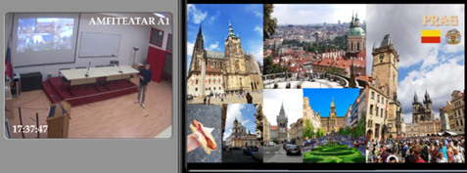
The Office for International Cooperation will continue to strive to provide as many opportunities as possible for students of the Pan-European University Apeiron.

