Pan-European University Apeiron
Report on the dissemination of the experience of participating in the Erasmus+ program


As part of the Erasmus+ program, the Pan-European University Apeiron is cooperating with the B2 Business School in Ljubljana. The European Union funds this project and financial resources have been allocated for the exchange of academic and non-academic staff as well as students.
Among the teaching staff, prof. Dr. Vesna Novaković and Prof. Dr. Jana Aleksić, from the Faculty of Business Economics. Their mobility took place in the period 10/04/2022-16/04/2022, where they held 2 lectures each for students at the Business School B2 in Ljubljana.
The goal of this exchange was the exchange of contacts with the teaching staff of the partner institution, the exchange of skills and knowledge from the home fields with both professors and students and the improvement of already existing knowledge. During their visit, the professors also contacted the professors in Ljubljana who are planning to visit the Apeiron Pan-European University in the coming period.
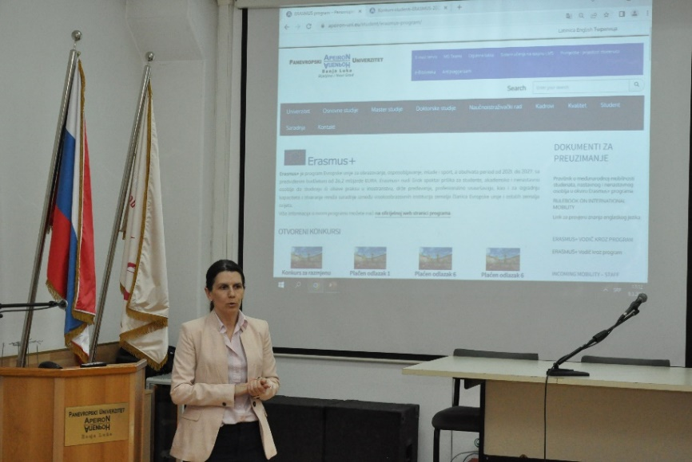
In order to better convey their experiences to other professors, but also to students, professors 29.04.2022. organized the dissemination of the experience of participating in the program, where they gave a presentation of their stay. During the presentation, they told their colleagues important information related to applying for the program and staying in Ljubljana, as well as the method and experience of preparing for the English language test. Also, they showed the attendees interesting and beautiful things they visited during their stay.

